CHAPTER TWO
LITERATURE REVIEW
2.1 Introduction
In recent years, the management of events has undergone a technological transformation, driven by the rapid growth in mobile computing, real-time communication, and user-centric software design. Event Management Systems (EMS) have evolved from basic manual methods and spreadsheet coordination to robust digital solutions that automate and simplify the entire event lifecycle. As institutions and organizations strive for more efficient planning, execution, and evaluation of events, digital tools particularly mobile applications have become indispensable.
This chapter presents a comprehensive review of relevant literature to support the development of a mobile-based Event Management System tailored for educational, social, and corporate use. It begins by examining the core concepts and principles of event management, followed by an exploration of the historical progression of EMS technologies. Emphasis is placed on the growing importance of mobile applications in this space, especially in regions where mobile devices are the primary means of accessing the internet (NCC, 2022). The review also critically analyzes existing EMS platforms such as Eventbrite, Cvent, and Whova, evaluating their functionalities, limitations, and market positioning.
Furthermore, the chapter identifies the challenges in current event coordination practices, particularly within low-resource or educational settings, where existing systems may be inaccessible, expensive, or ill-suited to local contexts. By analyzing both international literature and context-specific case studies, this review highlights gaps that the proposed system aims to fill namely, affordability, offline access, and user-friendliness for non-technical users.
Finally, this chapter introduces the theoretical frameworks guiding the study, including the Technology Acceptance Model (TAM) and User-Centered Design (UCD). These models provide a foundation for understanding user interaction with technology and inform the structure of the proposed EMS application.
2.2 Concept of Event Management System
Event management refers to the comprehensive process of planning, organizing, executing, and evaluating various types of events ranging from corporate meetings and academic conferences to weddings, concerts, exhibitions, and community gatherings. As a discipline, it integrates elements of logistics, finance, marketing, public relations, human resource management, and technology. The goal is to deliver an experience that fulfills both the objectives of organizers and the expectations of attendees (Gajanan, 2021).
The concept has significantly evolved in recent decades, moving from informal and manually coordinated setups to professionalized structures that rely heavily on digital tools. Contemporary event management is no longer just a series of administrative tasks but a strategic, dynamic, and creative process. It is increasingly recognized as a multidisciplinary field requiring project management skills, stakeholder coordination, risk mitigation, and data analytics. According to Dos Santos and Teixeira (2022), effective event management involves a combination of "creativity, logistical excellence, and audience engagement," reflecting its dual nature as both an art and a science.
One of the most prominent shifts in recent years is the role of digital technology, particularly mobile and cloud-based systems, in transforming how events are organized and experienced. Mobile platforms have enabled real-time communication, instant feedback, dynamic scheduling, and hybrid participation models. This transformation was accelerated by the COVID-19 pandemic, which necessitated the rapid adoption of digital formats for virtual and hybrid events (Ratten, 2020). Consequently, event managers now operate in a more technologically integrated environment where digital proficiency is as critical as traditional planning skills.
In academic settings, for instance, seminars, workshops, symposia, and graduation ceremonies are often integral to the institutional calendar. These events require coordination across multiple departments and stakeholders. Event management in this context focuses not only on logistics but also on content dissemination, participant engagement, and outcome evaluation. Mobile Event Management Systems (EMS) tailored for education now offer features such as personalized agendas, speaker bios, networking tools, and integration with Learning Management Systems (LMS), enhancing the educational value of such events (Okonkwo et al., 2023).
In the corporate sector, event management plays a key role in brand building, internal communication, and stakeholder engagement. Organizations use events such as product launches, conferences, and retreats to communicate strategy, reinforce culture, and build relationships. Here, EMS platforms enable seamless ticketing, RSVP tracking, access control, and post-event analytics. Moreover, artificial intelligence (AI) is increasingly used to personalize attendee experiences, recommend sessions, and improve audience targeting (Bourliataux-Lajoinie et al., 2022).
Social and cultural events, such as weddings, religious conventions, and festivals, place a premium on community participation and emotional resonance. In these contexts, event managers must be sensitive to traditions, language, and social dynamics. Mobile applications have proven effective in enhancing guest communication, coordinating vendors, and managing programs in real-time. Tools like QR code invitations, automated reminders, live streaming, and digital guestbooks have become standard in well-managed events (Efe & Oladipo, 2021).
Furthermore, the environmental and sustainability aspects of event management have gained prominence in recent years. Organizers are now expected to reduce waste, manage energy use, and measure carbon footprints. Mobile apps and cloud-based EMS platforms contribute positively by reducing the need for paper-based communication and enabling virtual attendance, which cuts down on travel-related emissions (Becchetti & Salustri, 2020).
Ultimately, the modern concept of event management is rooted in strategic thinking, efficient resource allocation, and real-time adaptability. With the increasing demands of diverse audiences and rapidly changing environments, event managers must combine planning rigor with creative flexibility. The integration of mobile Event Management Systems allows for streamlined operations, enhanced user engagement, and improved decision-making through data analytics.
By leveraging modern technology—especially mobile and cloud-based tools—event planners can provide seamless, engaging, and data-informed experiences that were previously impossible through manual or disjointed systems. This growing reliance on mobile EMS platforms underpins the need for systems that are user-friendly, customizable, affordable, and tailored to local contexts, especially in educational and low-resource environments.
2.3 Evolution of Event Management Technologies
The history of Event Management Systems (EMS) reflects the broader evolution of information technology and its increasing role in enhancing operational efficiency and user experience. Initially, events were managed through rudimentary methods such as handwritten notes, flyers, printed invitations, spreadsheets, bulletin boards, and word-of-mouth announcements. These traditional approaches were labor-intensive, error-prone, and lacked scalability, often resulting in miscommunication, redundant processes, and limited attendee engagement (Bourliataux-Lajoinie et al., 2022).
The 1990s and early 2000s saw the emergence of desktop-based software applications that introduced some level of automation to the planning and execution of events. These tools allowed organizers to create schedules, maintain guest lists, and send out invitations through email. However, they remained largely offline, requiring manual data entry and offering limited flexibility for real-time updates or remote collaboration (Dos Santos & Teixeira, 2022).
With the proliferation of the internet, web-based EMS platforms such as Eventbrite, Cvent, and Bizzabo began to gain popularity. These platforms enabled users to create event pages, manage registrations, send automated confirmations, and accept online payments. They also offered analytics dashboards, enabling organizers to track attendee metrics and generate reports. Despite these advancements, early web-based EMS tools were often designed for desktop use and lacked mobile optimization, limiting their utility in fast-paced or field-based event environments (Gajanan, 2021).
The introduction of smartphones and the expansion of mobile internet access fundamentally transformed the EMS landscape. Mobile Event Management Systems now offer seamless, real-time interaction among all stakeholders—organizers, attendees, vendors, and sponsors. These systems support a wide array of functionalities including mobile registration, QR code check-ins, push notifications, live streaming, interactive maps, polls, surveys, and feedback tools (Okonkwo et al., 2023). Their accessibility on handheld devices provides greater flexibility and control, enabling organizers to monitor events on the go and respond to issues instantly.
This mobile-centric evolution became especially prominent during and after the COVID-19 pandemic. As restrictions on physical gatherings disrupted traditional events, there was a massive shift toward virtual and hybrid formats. EMS platforms evolved rapidly to include integrations with video conferencing tools, virtual exhibitor booths, and digital networking lounges. This transformation not only expanded the geographic reach of events but also highlighted the value of EMS in supporting continuity and inclusivity (Ratten, 2020).
Today’s EMS platforms are characterized by their scalability, customization, cloud-based architecture, and data-driven intelligence. Many systems now incorporate artificial intelligence (AI) and machine learning (ML) to enhance personalization, predict attendee preferences, and optimize marketing campaigns (Bourliataux-Lajoinie et al., 2022). Some platforms even use facial recognition for contactless check-in, chatbots for real-time support, and blockchain for secure ticketing and credential verification.
In academic, business, and social contexts, the role of EMS has expanded from simple logistical tools to strategic assets. In universities, EMS applications streamline the coordination of orientations, lectures, and graduation ceremonies. In corporate environments, EMS software is used to manage conferences, product launches, and internal communications. In the social domain, mobile EMS tools assist in planning weddings, festivals, and fundraisers by coordinating vendors, tracking guest lists, and providing real-time updates (Efe & Oladipo, 2021).
Importantly, EMS platforms now cater to the needs of low-resource settings, with lightweight versions that work offline or with intermittent internet access. This is particularly useful in developing countries, where mobile-first technologies are essential due to the limited availability of desktops or broadband. Developers increasingly focus on designing EMS apps that are data-efficient, multilingual, and compatible with low-end devices—making them more inclusive and locally adaptable (Okonkwo et al., 2023).
2.4 Mobile Applications in Event Management
The integration of mobile technology into event management has dramatically reshaped the way events are organized, executed, and experienced. Mobile applications have become essential tools for both organizers and attendees, enabling real-time communication, data sharing, engagement, and coordination through handheld devices. In today’s fast-paced and mobile-first world, mobile Event Management Systems (EMS) offer convenience, portability, and dynamic functionalities that surpass traditional and even web-based systems.
One of the key advantages of mobile applications in event management is their ability to facilitate real-time interaction. Features such as push notifications allow organizers to send instant updates regarding schedule changes, venue modifications, or emergency alerts. This keeps attendees informed and minimizes confusion, particularly during large or multi-day events. According to Bourliataux-Lajoinie et al. (2022), real-time updates and communication are crucial in increasing participant satisfaction and reducing stress during events.
Mobile EMS platforms also support digital ticketing and check-ins, which eliminate the need for physical tickets and long queues. Through QR codes and NFC technology, attendees can be verified swiftly at entry points, improving crowd control and reducing staffing needs. This not only enhances the user experience but also ensures safety and compliance with health regulations, especially in post-pandemic event environments (Okonkwo et al., 2023).
Another impactful feature of mobile EMS apps is live polling and interactive Q&A sessions, which enable two-way communication between speakers and participants. These tools promote audience participation, collect immediate feedback, and provide valuable insights to organizers. Additionally, surveys and rating systems built into mobile apps can gather data on session effectiveness, speaker performance, and logistics, helping planners continuously refine their strategies (Efe & Oladipo, 2021).
Mobile applications also contribute significantly to operational efficiency. Event organizers can monitor attendance, manage schedules, assign tasks, and receive reports in real-time. The ability to coordinate multiple aspects of an event through a single platform reduces redundancy and error. These efficiencies are particularly important for smaller teams or volunteer-driven events where resource constraints are common (Dos Santos & Teixeira, 2022).
Moreover, mobile EMS platforms are inherently user-centered, with intuitive interfaces and customizable features. Personalization options allow users to create individualized agendas, bookmark sessions, and receive tailored content. Many applications now employ artificial intelligence (AI) to recommend sessions based on user interests, improving the overall event experience (Bourliataux-Lajoinie et al., 2022).
The significance of mobile EMS is even more pronounced in regions with high smartphone penetration but limited access to desktop computing, such as many parts of Africa and Asia. In these contexts, mobile apps provide a more inclusive and scalable solution for event coordination. Okonkwo et al. (2023) highlight that in African universities, mobile EMS platforms have helped automate orientation, academic conferences, and graduation planning processes that were previously manual and chaotic.
Furthermore, mobile apps support hybrid and virtual event models, which have grown in popularity since the COVID-19 pandemic. Features like live streaming, chat rooms, and virtual exhibitor booths allow users to participate from anywhere in the world. This not only broadens event reach but also makes events more sustainable by reducing the need for travel and printed materials (Becchetti & Salustri, 2020).
In the context of data collection and analytics, mobile EMS platforms offer advanced dashboards that help organizers track KPIs such as registration rates, engagement levels, feedback scores, and post-event retention. These analytics support data-driven decision-making and demonstrate the return on investment (ROI) of events to sponsors and stakeholders.
Finally, mobile applications offer cost-effectiveness. By reducing dependence on physical infrastructure and printed materials, mobile EMS tools lower the cost of organizing events. Many platforms operate on a Software-as-a-Service (SaaS) model, allowing organizers to scale features according to their budget and needs.
2.5 Review of Related Literature
The rapid development of digital Event Management Systems (EMS) has stimulated significant academic interest, with studies exploring their benefits, adoption challenges, and contextual applications across different sectors. EMS platforms have evolved into multifunctional tools supporting event planning, registration, ticketing, communication, and analytics (Gajanan, 2021). Researchers have examined how EMS technologies improve efficiency, reduce human error, and enhance participant engagement, particularly in education, corporate, and social environments (Okonkwo et al., 2023).
Several scholars identify efficiency and automation as primary benefits. For example, Bourliataux-Lajoinie et al. (2022) highlighted how AI-driven personalization in platforms like Bizzabo supports improved attendee experience by recommending relevant content and sessions. In contrast, Liu et al. (2021) argue that while these features are beneficial for enterprise events, they often overlook users in smaller-scale or educational contexts due to cost and complexity.
Technological usability also plays a major role in system success. User-Centered Design (UCD) frameworks are frequently applied to ensure intuitive interfaces and responsiveness. According to Dos Santos and Teixeira (2022), systems developed with UCD principles reduce learning curves and increase adoption, particularly among non-technical users. This supports the Technology Acceptance Model (TAM), which posits that perceived usefulness and ease of use are essential for successful technology adoption.
In educational settings, EMS tools like Whova have been praised for their networking capabilities and integration with learning management systems (Efe & Oladipo, 2021). Mobile EMS platforms are increasingly essential in resource-constrained academic environments, where smartphones are more accessible than desktop systems. However, literature also identifies gaps many EMS platforms are designed for well-funded institutions, offering limited support for offline functionality or localized interfaces.
The corporate sector has seen the fastest adoption of EMS technologies, using platforms like Cvent for managing large conferences and internal events. These tools enable real-time data collection and post-event analytics, aiding in return-on-investment evaluations. Yet, Gajanan (2021) emphasizes the risk of data overload and the need for systems that prioritize actionable insights over raw data.
Social and community events, such as weddings or festivals, are less frequently covered in academic literature. Yet, they represent a substantial user base. Research by Becchetti and Salustri (2020) suggests that mobile EMS tools offer critical benefits in these settings, especially in terms of cost, portability, and real-time coordination.
Overall, gaps in the literature include limited focus on mobile-first EMS for low-resource environments, inadequate attention to localized payment and language support, and minimal study of EMS performance in rural or grassroots contexts. These gaps provide justification for the development of an accessible, mobile EMS platform tailored to educational and social event organizers in emerging economies.
2.6 Review of Existing Event Management Systems
The Event Management System (EMS) landscape has grown significantly over the past decade, with various platforms emerging to address the diverse needs of event planners across industries. Existing EMS platforms reflect a range of capabilities, from basic event registration to complex enterprise-grade features like AI personalization, hybrid event hosting, and real-time analytics. However, these systems also reveal significant gaps particularly in affordability, accessibility, and relevance to low-resource environments or educational settings. A critical review of leading EMS platforms such as Eventbrite, Cvent, Bizzabo, and Whova reveals both their strengths and limitations.
Eventbrite
Eventbrite is one of the most widely recognized EMS platforms, known for its intuitive interface and ease of use. It allows organizers to create events, sell tickets, manage RSVPs, and communicate with attendees via email and mobile notifications. Its self-service model is particularly popular among small-to-medium-sized event organizers, including community-based organizations and freelance planners. However, while Eventbrite offers free services for free events, it charges significant transaction fees for paid events, which can become burdensome for large-scale or nonprofit events with limited budgets (Dos Santos & Teixeira, 2022). Additionally, Eventbrite’s customization capabilities are somewhat limited, making it less suitable for complex or highly branded events.
Cvent
Cvent is considered an enterprise-grade solution designed for large corporations, academic institutions, and government bodies. It offers an extensive feature set including registration, session management, venue sourcing, check-in services, analytics, and integrations with CRM tools. One of Cvent’s notable advantages is its capacity to handle multi-session, multi-day conferences with thousands of attendees. According to Liu et al. (2021), Cvent’s scalability makes it ideal for Fortune 500 companies and multinational conferences. However, this platform is often criticized for being expensive and overly complex for small teams or individual organizers. Its steep learning curve and licensing costs limit its applicability in developing countries and informal event sectors.
Bizzabo
Bizzabo is a modern EMS platform that focuses heavily on personalization and audience engagement, integrating AI to offer content recommendations and targeted communications. It is optimized for hybrid and virtual events, supporting live streaming, digital booths, and interactive breakout sessions. Bizzabo also provides robust analytics for tracking attendee behavior and ROI. While these features are powerful for corporate and tech-driven events, they are less relevant to educational or social event organizers who may not require such complexity (Bourliataux-Lajoinie et al., 2022). Additionally, Bizzabo’s pricing structure and focus on enterprise clients limit its accessibility for grassroots users or institutions in low-income regions.
Whova
Whova is a mobile-first EMS platform that excels in academic, nonprofit, and professional development settings. It is particularly praised for its networking tools, interactive agenda features, live polling, and ability to handle virtual and hybrid events. Universities and research institutions often adopt Whova to host academic conferences and workshops due to its attendee-friendly design and strong support for session feedback and document sharing. Okonkwo et al. (2023) note that Whova's integration with mobile devices and its affordability make it more adaptable in educational environments. However, while Whova performs well in knowledge-sharing events, it lacks some of the branding flexibility and high-end integrations offered by more corporate-focused platforms.
Limitations and Gaps
Despite their advantages, each of these platforms presents limitations that highlight opportunities for innovation. First, cost remains a major barrier. Most high-functionality EMS platforms operate on a subscription or usage-based pricing model, making them inaccessible to smaller organizations or users in developing regions. Second, usability and complexity present challenges. Platforms like Cvent and Bizzabo, while rich in features, often require extensive onboarding and technical support, which is impractical for short-term or volunteer-led events (Gajanan, 2021).
Another major gap lies in customizability for mobile-first environments. Although most modern platforms offer mobile apps, they are typically secondary to the web-based experience. In regions where mobile is the primary or only form of internet access, there is a need for EMS platforms that are designed primarily for smartphones, with offline functionality and low data consumption. Furthermore, language support, local payment integration, and offline capabilities are often lacking, limiting these platforms' relevance in rural and underserved areas (Efe & Oladipo, 2021).

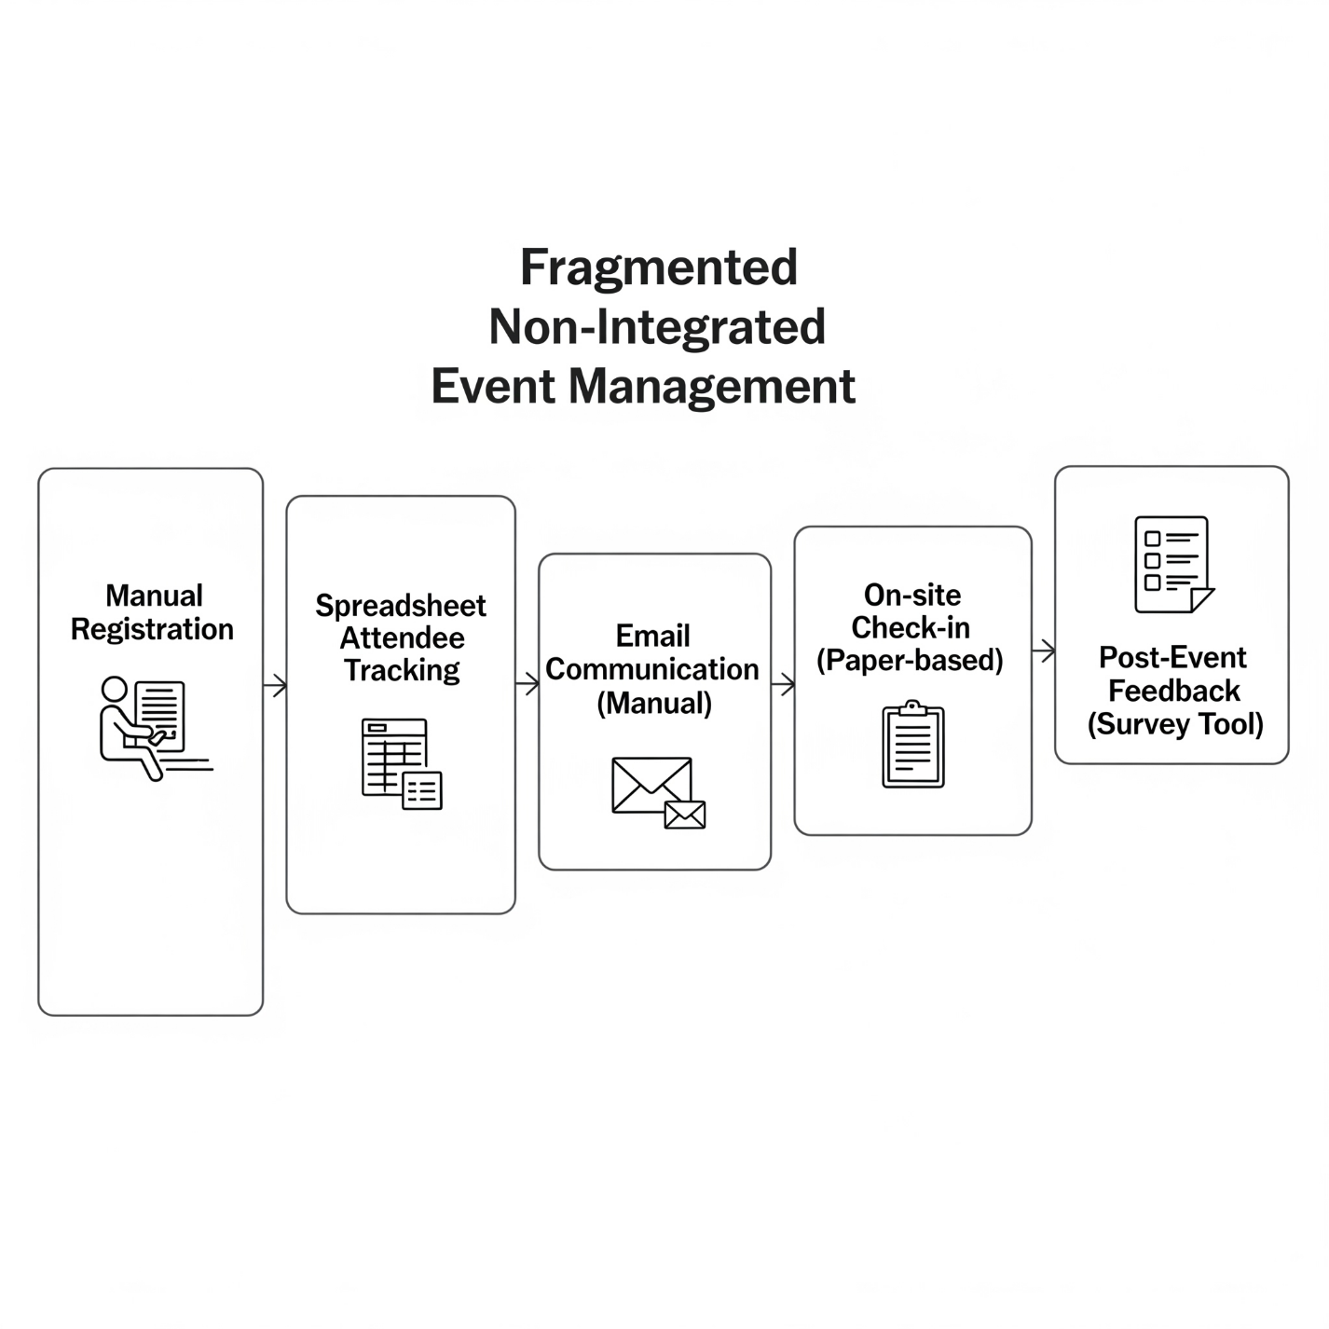
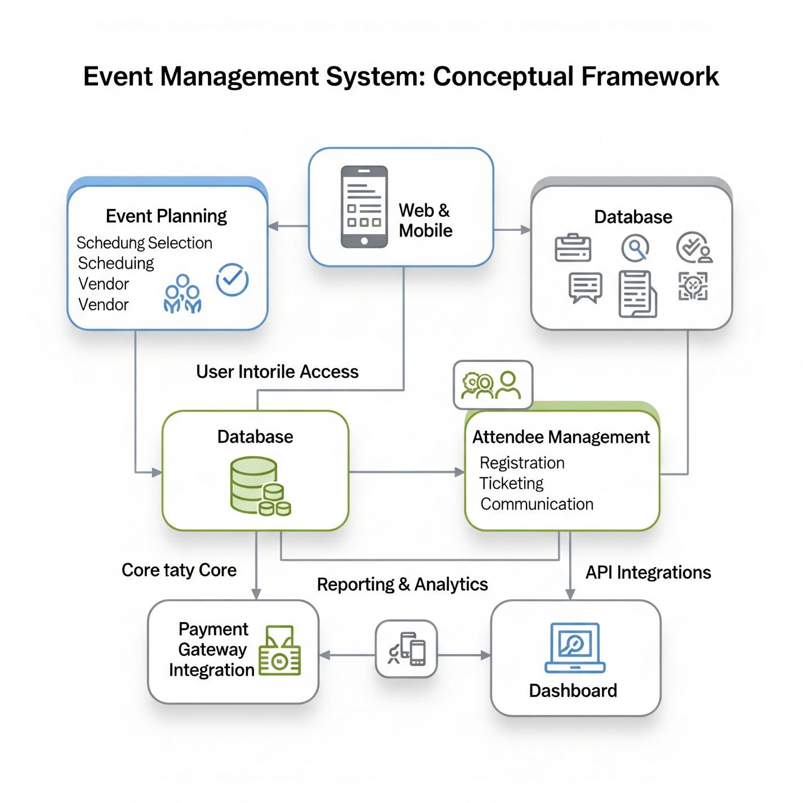
2.7 Importance of EMS in Education, Social, and Corporate Events
Event Management Systems (EMS) have increasingly become pivotal across various domains, notably in education, social functions, and corporate settings. With the rise of digital transformation and mobile technology, EMS platforms now facilitate not just the automation of event planning, but also the enhancement of participant engagement, coordination efficiency, data collection, and feedback mechanisms. The integration of EMS with mobile applications and cloud-based systems has enabled greater accessibility, responsiveness, and customization, making them an essential tool for modern event organizers (Chung & Lee, 2021).
2.7.1 EMS in Educational Events
In academic institutions, EMS plays a critical role in organizing events such as matriculations, orientation programs, graduation ceremonies, public lectures, research conferences, and alumni reunions. These events typically involve a wide array of participants, including faculty members, students, invited guests, and administrative personnel. Without efficient coordination mechanisms, such events can become disorganized and ineffective. EMS platforms address these challenges by offering centralized dashboards for planning, scheduling, registration, communication, and post-event analysis.
According to Okonkwo et al. (2023), Nigerian universities that adopted mobile-based EMS platforms during and after the COVID-19 pandemic reported a significant improvement in event logistics, especially in managing student-heavy events. The EMS allowed for automated invitation handling, real-time updates via push notifications, and streamlined registration processes, eliminating delays and reducing human error.
Further, EMS applications often include hybrid and virtual event capabilities. This was particularly important during the global lockdowns, when academic institutions were forced to shift many of their events online. Platforms with Zoom or Microsoft Teams integration allowed faculty meetings, academic presentations, and seminars to proceed with minimal disruption. As Li and Wang (2021) note, EMS technologies were instrumental in ensuring the continuity of academic engagement during periods of global crisis.
Features such as multilingual interfaces, accessible design, and user-focused dashboards also ensure that diverse student populations including those with disabilities can participate equitably. According to Rashid et al. (2022), inclusive EMS tools help foster a more accommodating academic environment, thus promoting institutional diversity goals.
2.7.2 EMS in Social Events
Social events ranging from weddings and birthdays to religious gatherings and cultural festivals benefit significantly from EMS adoption. Planning such events often involves managing multiple stakeholders: guests, venues, vendors, performers, and service providers. Mobile EMS tools make it easier for users to coordinate these elements using features like guest list automation, RSVP tracking, seating arrangements, digital invitations, live updates, and vendor management.
Efe and Oladipo (2021) highlight the increasing popularity of EMS tools in urban Nigerian settings, especially among millennials planning weddings and religious events. The tools’ ability to send automated reminders, integrate mobile payments, and manage venue logistics remotely has made them a popular choice. The use of QR-coded entry passes, e-ticketing systems, and digital maps helps avoid long queues and enhances guest convenience.
Event-specific EMS platforms, such as WeddingWire or Joy, provide even more specialized functionality. These include budgeting tools, checklist templates, vendor marketplaces, and registry integrations. These tools significantly reduce the stress involved in planning, especially for users without prior event coordination experience. Asad and Khan (2022) found that over 70% of users who used event management apps for social events reported higher satisfaction and reduced financial mismanagement.
Additionally, social EMS apps are often integrated with social media platforms. This not only supports real-time sharing and audience engagement but also creates a digital archive of the event. According to Thomas and Mutuku (2021), the ability to sync EMS tools with Instagram, Facebook, or WhatsApp significantly enhances outreach and helps maintain guest engagement before, during, and after the event.
2.7.3 EMS in Corporate Events
The corporate sector is arguably where EMS platforms have demonstrated the most sophisticated capabilities. Corporate events including trade shows, product launches, annual general meetings (AGMs), investor briefings, webinars, and internal training require high levels of planning, coordination, branding, and documentation. In this space, EMS tools provide a comprehensive suite of functions: online registration, session scheduling, speaker management, real-time feedback, data analytics, and post-event reporting.
Bourliataux-Lajoinie et al. (2022) explain that EMS adoption in the corporate world is not merely about convenience it is about strategic value creation. For example, corporate EMS tools integrate with Customer Relationship Management (CRM) systems like Salesforce, allowing organizations to turn event attendance into sales leads and post-event marketing campaigns. This integration supports goal alignment across departments, from marketing and communications to sales and IT.
Advanced corporate EMS tools such as Bizzabo, Cvent, and Hopin offer AI-driven features like smart matchmaking for networking, predictive analytics for registration trends, and sentiment analysis from live feedback. These features enable data-driven decision-making that enhances the Return on Investment (ROI) for events. According to Smith & Alper (2023), companies using such platforms saw a 30% improvement in attendee retention and a 25% reduction in no-show rates.
Another key benefit of EMS in corporate contexts is risk management. Features such as automated backups, compliance with data protection laws (e.g., GDPR), and security protocols for ticketing and identity verification help minimize operational risks. In an era of increasing cybersecurity threats, these functions have become essential.
Finally, corporate EMS platforms enable sustainability through paperless operations, digital ticketing, and remote participation. This is aligned with broader Environmental, Social, and Governance (ESG) goals pursued by many global firms. Nguyen & Fadeyi (2024) argue that EMS tools contribute to corporate sustainability objectives by minimizing environmental impact without compromising event effectiveness.
2.7.4 Cross-Sector Implications
Across all sectors education, social, and corporate the common thread is the need for streamlined coordination, real-time communication, and data collection. Mobile EMS applications stand out because of their ubiquity, accessibility, and affordability, particularly in regions with limited infrastructure. They eliminate the need for paper-based workflows and allow users to interact with event content seamlessly.
As mobile penetration continues to increase globally, EMS tools must become more inclusive, scalable, and intuitive. Platforms that adopt modular architecture, multilingual support, and AI capabilities will be better positioned to meet the diverse needs of these sectors.
2.8 Technology Acceptance Model (TAM)
The Technology Acceptance Model (TAM) is one of the most influential models used to explain and predict user behavior toward new technologies. Originally developed by Davis (1989), its core principles remain highly relevant in today’s mobile and cloud computing environments. The model suggests that two main factors Perceived Usefulness (PU) and Perceived Ease of Use (PEOU) directly influence users’ attitudes toward a system and their intention to use it.
Contemporary applications of TAM continue to validate its significance in mobile system adoption. For example, Akbar and Ahsan (2021) investigated TAM in the context of mobile learning systems and confirmed that perceived ease of use and usefulness significantly influence users' behavioral intentions in mobile app environments. Similarly, Ghosh et al. (2022) applied TAM to mobile event applications and found a strong correlation between ease of use and attendee engagement.
In the context of this EMS project, Perceived Usefulness refers to how well the mobile app enables users to create, manage, and attend events efficiently. Perceived Ease of Use addresses how intuitively users can navigate and perform tasks such as registration, RSVP, and feedback submission. These constructs help inform UI/UX decisions to ensure the system lowers the barrier to entry and provides value to its intended users.
User-Centered Design (UCD)
While TAM offers insight into the psychology of technology adoption, User-Centered Design (UCD) serves as a complementary framework focusing on how the system should be developed. UCD is an iterative design philosophy that emphasizes understanding users' needs, preferences, and limitations throughout the development process. It involves continuous user involvement from the ideation phase through to design, prototyping, testing, and implementation (ISO 9241-210:2019).
Recent studies highlight the growing relevance of UCD in mobile application development. Mendoza-Gonzalez et al. (2020) emphasized that UCD practices increase system usability, reduce post-deployment costs, and enhance user satisfaction in mobile health and education apps. Similarly, Rao et al. (2021) applied UCD principles in designing digital systems for public services and reported better usability scores and higher adoption rates.
For this project, UCD informs the inclusion of features that align with actual user workflows. For instance, the design considers the needs of three major groups: event organizers, attendees, and system administrators. Prototypes are evaluated through user feedback, and revisions are made to address pain points such as navigation difficulty or unclear labeling. Accessibility concerns, including language preferences and support for users with disabilities, are also taken into account through UCD practices.

Complementary Use of TAM and UCD
The integration of TAM and UCD provides a holistic framework for EMS development. TAM ensures that the app meets behavioral expectations regarding usefulness and ease, while UCD ensures the system's design is iteratively aligned with user experience goals. When applied together, they allow for a balance between system functionality and usability.
As demonstrated by Alharthi and Aljuaid (2022), combining TAM and UCD methodologies can significantly increase the effectiveness of mobile solutions in real-world contexts. In their study on mobile government services, systems designed with UCD principles and evaluated through TAM constructs showed increased adoption rates and improved long-term engagement. Applying this synergy to an EMS platform ensures it is not only adopted quickly but also remains valuable over time.
2.9 Summary of Literature Review
This chapter explored the theoretical and empirical foundations relevant to the design and implementation of a mobile-based Event Management System (EMS). Beginning with the concept of event management, the review highlighted how event planning has evolved from manual, fragmented processes to digitally enhanced systems that support complex coordination across education, corporate, and social domains.
The review traced the evolution of EMS platforms, showing how digital transformation particularly the proliferation of mobile technology has catalyzed a shift toward mobile-first, real-time, and user-centric event solutions. Traditional systems that relied on spreadsheets and manual communication have largely been replaced by platforms such as Eventbrite, Cvent, Whova, and Bizzabo. These platforms demonstrate both the functional strengths of modern EMS and the limitations they present in terms of accessibility, affordability, and suitability for low-resource contexts.
The section on mobile applications in event management underscored the impact of smartphones in enhancing event experiences. It emphasized how features like push notifications, digital ticketing, live updates, and feedback collection improve operational efficiency and participant engagement. These insights are critical in justifying the choice of a mobile app for this project.
A critical review of existing systems revealed significant gaps in the EMS market, particularly the need for lightweight, customizable platforms that serve institutions and communities in resource-constrained environments. This directly informs the rationale for developing a mobile EMS tailored to educational, corporate, and social use cases in contexts like Nigeria, where mobile accessibility often surpasses desktop or enterprise infrastructure.
Furthermore, the literature highlighted the importance of EMS in various domains. In education, EMS platforms streamline processes like academic conference management and graduation planning. In corporate contexts, they support branding, analytics, and engagement in events such as training and product launches. In social settings, EMS platforms facilitate RSVP tracking, vendor coordination, and guest communication especially for weddings and cultural events.
To ground the study, the review introduced two theoretical models: the Technology Acceptance Model (TAM) and the User-Centered Design (UCD) framework. These theories provide dual lenses behavioral and design-based for understanding user interaction with the EMS. TAM explains technology adoption through perceived ease of use and usefulness, while UCD ensures that the system is developed iteratively with direct user feedback, thus promoting usability and satisfaction.
In summary, the reviewed literature establishes the need, relevance, and theoretical foundation for developing a mobile-based EMS. It identifies gaps in existing platforms, outlines user expectations, and proposes design principles for building a system that is accessible, user-friendly, and applicable across various event categories. These insights form the basis for the next chapter, which details the methodology used to design, develop, and evaluate the proposed mobile application.

